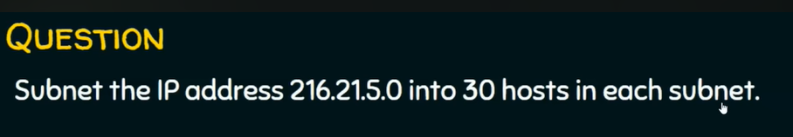

If you are using aws:

Subnet mask Class C

255.255.255.0

216.21.5.0/26 ---- 64

255.255.255.192

216.21.5.0 – 216.21.5.63

216.21.5.64 – 216.21.5.127

216.21.5.128 – 216.21.5.191

216.21.5.192- 216.21.5.255

